Module:4-Hierarchical Clustering

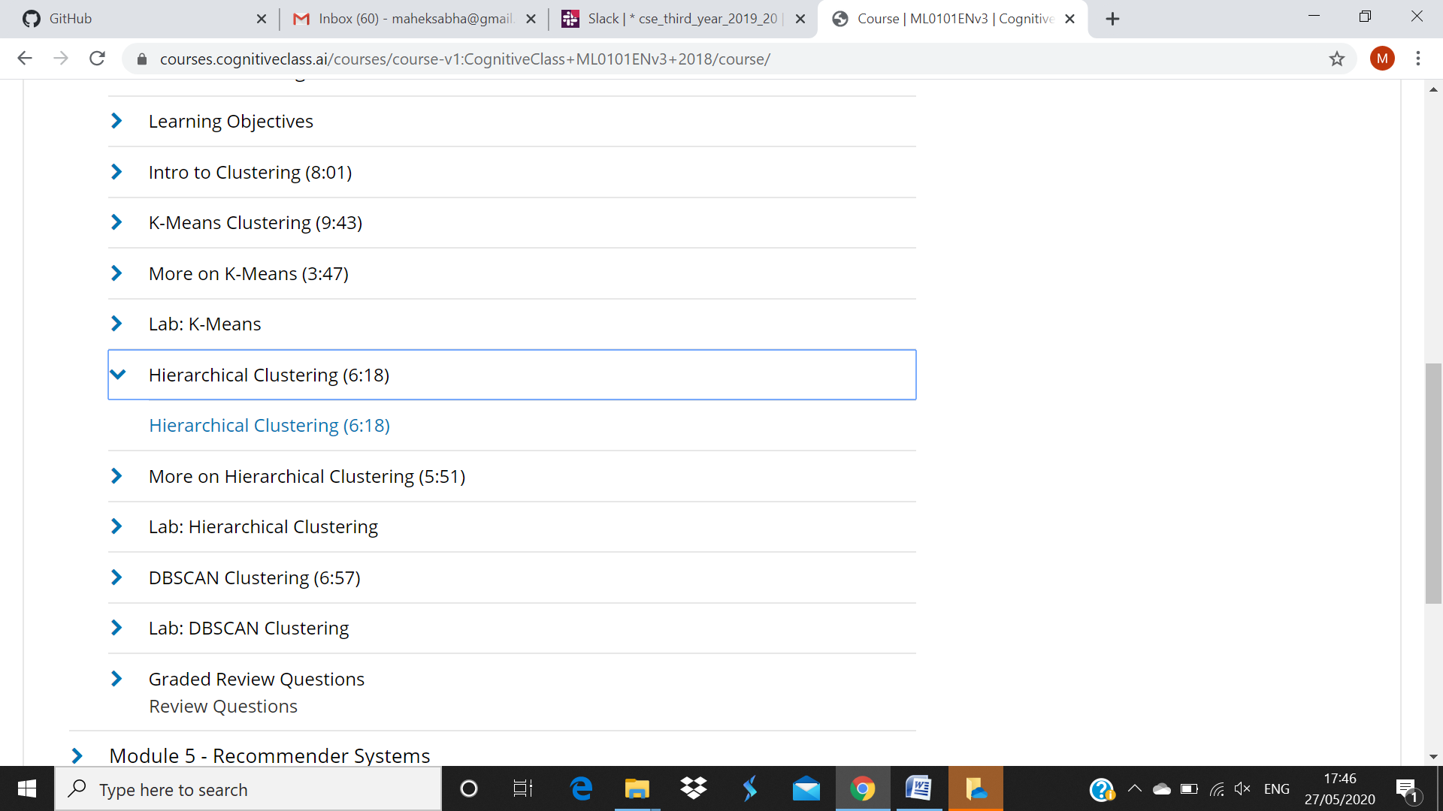

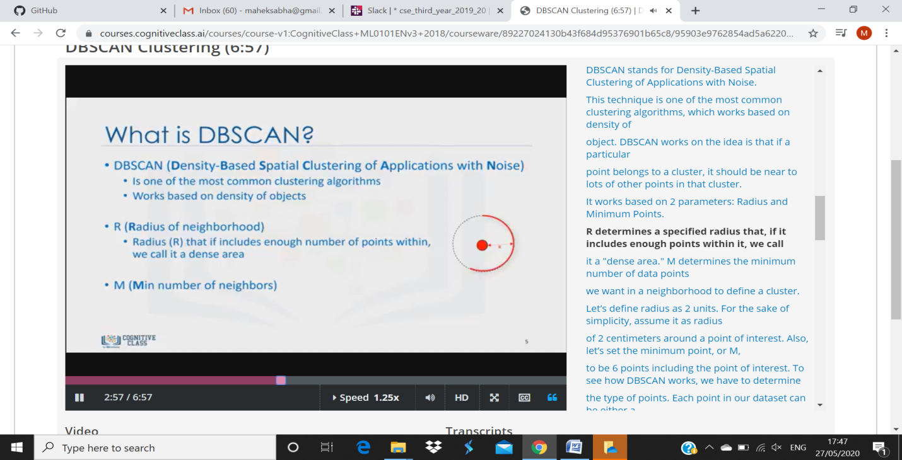

The maximum distance between two samples for one to be considered as in the neighborhood of the other. This is not a maximum bound on the distances of points within a cluster. This is the most important DBSCAN parameter to choose appropriately for your data set and distance function.